Write a Custom JDBC Userstore Manager

Introduction

In the custom user store, you can have any type of schema according to your wish. Suppose you have a company that already has a user database and needs to authenticate the user through our WSO2 Identity Server. In that case, you don’t have to convert your whole database to the WSO2 Identity Server standard schema.

Sample scenario
Consider a sample scenario where you want to use a custom hashing method using a 3rd party library such as Jasypt and to do this, you need to override the doAuthentication and preparePassword methods.

Write a custom userstore
Follow the steps given below.
- Create a new Apache Maven project with the help of the IDE that you are using.
- Create a new class by extending the existing UniqueIDJDBCUserStoreManager implementation.
package org.wso2.custom.user.store.internal;

public class CustomUserStoreManager extends UniqueIDJDBCUserStoreManager {

- Override the doAuthenticateWithUserName method to write custom authentication logic and preparePassword method to hash the passwords using Jasypt.
package org.wso2.custom.user.store;

public class CustomUserStoreManager extends UniqueIDJDBCUserStoreManager {

private static final Log log = LogFactory.getLog(CustomUserStoreManager.class);

private static final StrongPasswordEncryptor passwordEncryptor = new
StrongPasswordEncryptor();

public CustomUserStoreManager() {}

public CustomUserStoreManager(RealmConfiguration realmConfig,
Map<String, Object> properties, ClaimManager claimManager,
ProfileConfigurationManager profileManager, UserRealm realm,
Integer tenantId) throws UserStoreException {

super(realmConfig, properties, claimManager, profileManager, realm, tenantId);
log.info("CustomUserStoreManager initialized...");
}

@Override
public AuthenticationResult doAuthenticateWithUserName(String userName,
Object credential) throws UserStoreException {

// custom authentication logic.
}

@Override
protected String preparePassword(Object password, String saltValue)
throws UserStoreException {

if (password != null) {
String candidatePassword = String.copyValueOf(((Secret)password)
.getChars());
// ignore saltValue for the time being
log.info("Generating hash value using jasypt...");
return passwordEncryptor.encryptPassword(candidatePassword);
} else {
log.error("Password cannot be null");
throw new UserStoreException("Authentication Failure");
}
}

private AuthenticationResult getAuthenticationResult(String reason) {

AuthenticationResult authenticationResult = new AuthenticationResult(
AuthenticationResult.AuthenticationStatus.FAIL);
authenticationResult.setFailureReason(new FailureReason(reason));
return authenticationResult;
}
}

- Register as an OSGi service.
package org.wso2.custom.user.store.internal;

@Component(name = "custom.jdbc.user.store.mgt.component",
immediate = true)
public class CustomJDBCUserStoreMgtComponent {

private static Log log = LogFactory.getLog(CustomJDBCUserStoreMgtComponent.class);
private static RealmService realmService;

@Activate
protected void activate(ComponentContext ctxt) {

UserStoreManager customUserStoreManager = new CustomUserStoreManager();
ctxt.getBundleContext().registerService(UserStoreManager.class.getName(),
customUserStoreManager, null);
log.info("CustomUserStoreManager bundle activated successfully..");
}

@Deactivate
protected void deactivate(ComponentContext ctxt) {

if (log.isDebugEnabled()) {
log.debug("Custom User Store Manager is deactivated ");
}
}

@Reference(
name = "RealmService",
service = org.wso2.carbon.user.core.service.RealmService.class,
cardinality = ReferenceCardinality.MANDATORY,
policy = ReferencePolicy.DYNAMIC,
unbind = "unsetRealmService")
protected void setRealmService(RealmService rlmService) {

realmService = rlmService;
}

protected void unsetRealmService(RealmService realmService) {

realmService = null;
}
}

Prerequisites
- A Wso2 Identity Server setup.
- Please verify that all the system requirements are satisfied.
- MySQL driver added to the <IS_HOME>/repository/components/lib/ folder
- An Application registered in Identity Server.
- An application deployed in Tomcat server.
Ex: pickup-dispatch application

Set up
We have implemented a sample custom event handler for you. You can access that from here. Follow the below instructions after cloning the sample-is repo into your local machine.
- Navigate to the <SAMPLE_IS>/user-mgt/custom-jdbc-user-store-manager directory and run the following command.
mvn clean install

- Copy the generated JAR file in the target folder into the <IS-HOME>/repository/components/dropins/ directory.

- Add the following configuration to the <IS_HOME>/repository/conf/deployment.toml file to use our custom implementation for user store management.
[user_store_mgt]
custom_user_stores=["org.wso2.custom.user.store.CustomUserStoreManager"]

- Navigate to <IS_HOME>/bin and start the server by issuing one of the following commands based on your operating system:
- Create a database called custom_db and run the <IS-HOME>/dbscripts/mysql.sql file against the database created.
- Create a user store with the custom user store manager you created.
- Click User Attributes & Stores > User stores > New User Store.
- Select the custom user store manager you just created.
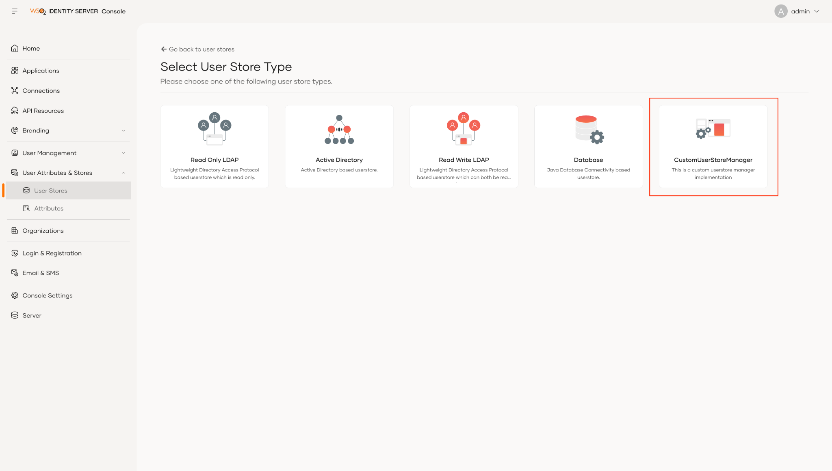
- Add the data related to custom_db connection details.
- Click Finish.

Try it out
Follow the steps given below.
- Create a user under the CUSTOM userstore created.
- You should see the below server logs in your Identity Server Console.

